IES Suite Installation Instructions

Change History

Rev# | Date | Information Affected | Authored
1 | 5/30/2018 | Initial Document | Dusan Palider
2 | 3/27/2019 | Adding GenBOE Auto Backup | Dusan Palider

Table of Contents
About 4
Getting Started 4
Initial IIS Setup 5
Unpack the installation ZIP file 5
Database Deployment 6
Web Application Deployment 6
PTM Emailer Application Installation 6
RDM Data Replication Application Installation 6
GenBOE Data Backup Application Installation 6
SSRS Server Setup 7
Appendix A: PTM Database Script Customization 8
Appendix B: IES Web.Config Customization 8
Appendix C: PTM Web.Config Customization 9
Appendix D: RDM Web.Config Customization 10
Appendix E: RDSB Web.Config Customization 11
Appendix F: PTM Emailer - App.Config Customization 12
Appendix G: RDM Data Replication - App.Config Customization 12
Appendix H: GenBOE Auto Backup - App.Config Customization 13

About
This document provides instructions on how to deploy a new instance of the IES suite of tools. Specifically IES portal, PTM, RDM and RDSB.
We are assuming that GenBOE has already been installed.

Getting Started
- Servers - we are assuming you will use the same application & database servers as the GenBOE application.
- A resource account that will run the applications. We recommend using the one you have for GenBOE.
- DNS entries / URLs for new applications:
  - IES
  - PTM
  - RDM
  - RDSB
- SSRS Server
  - Used by PTM, more information below
- New Databases, more information below
  - PTM
    - Create a SQL server account that the SSRS server will use. Name it generationReporter or you will cause the DB scripts to keep failing. Permissions will be granted via scripts
  - IES
- New AD Groups
  - Admin group - should reuse one from GenBOE if possible; should contain Frank, Tim and server admins; will be used by all apps, and control access to error logs
    - Our value: us\EBS.EstimationInitiative.DevTeam
  - User group – should reuse one from GenBOE if possible; will contain all application users; will be used by all apps
  - Additional application specific groups for PTM:
    - LeadEstimators
    - PricingVerification
    - IndependentReviewers
      - In our prod system, the above 3 are combined into a single group
      - us\EBS.IES.LeadEst.PricingVer.IndependentRev.Roles
    - LOBLeads
      - Our value: us\EBS.IES.LOBLeads
    - CoverSheetApprovers
      - Our value: us\EBS.IES.CoverSheetApprovers

Initial IIS Setup
- Create new directories that will hold each of the sites (e.g. E:\web_folders\PTM)
  - IES
  - PTM
  - RDM
  - RDSB
- Create a new App Pool for each of the applications
  - Select .NET framework 4
  - Select Integrated for the manage pipeline mode selection
- Configure the App Pools
  - Right click on each of the App Pools created above
  - Select Advanced Settings
  - Set the identity property to the resource account you had previously created (as listed in iii)
- Create new websites
  - Set the appropriate App Pools from step 4
  - Set the physical path to paths from step 2
  - Set the binding type to http
    - Unless you can use https, which we do on all of our production applications; that setup / configuration would be up to you
  - Set the port to a free port, other than 80 such as 8080
- Add a new binding to the sites, setting them to the appropriate DNS entries
- Configure the site authentication
  - Enable Windows Authentication
  - Disable Anonymous Authentication
- Add read permissions to the application directories, for the App Pool identity (resource account as listed in ii)
  - Depending on the setup, your user AD group may also need a read access
- Add write permissions to the Log directories in the individual application directories, for the App Pool identity (resource account as listed in ii)

Unpack the installation ZIP file
- Copy the deployment zip packages to the local server, extract all files to a temporary location.
- The package should contain the following folders:
  - IES.Web
  - PTM.Web
  - RDM.Web
  - RDSB.Web
  - PTM Emailer
  - RDM Data Replication
  - GenBOE Auto Backup
  - SSRS Files
  - PTM Database Scripts
  - IES Database Scripts

Database Deployment
- For each of the scripts (PTM and IES), locate the script files.
- Before executing the scripts, PTM database needs to be customized (Appendix)
- Open and execute the scripts, following the indicated order in both files & folders (if applicable)

Web Application Deployment
- Copy the folder contents to the appropriate the web application folders.
- Configure application settings by following steps described in the Appendixes
- Test the sites by navigating to the sites address. Verify the home pages are displayed.

PTM Emailer Application Installation
- Application executable: GenTracEmailScheduler.exe
- Customize the application based on the Appendix
  - The GenTracEmailScheduler.exe.config file
- The application needs to be scheduled to run once an hour, under the service account that has permissions to the PTM / GenTrac database. We use the same service account that runs the PTM web application.
  - The application has a switch in the configuration that considers time and day of the week in the actions it takes, making it dormant in the evenings and during the weekends

RDM Data Replication Application Installation
- Application executable: RDMClassifiedDeployment.exe
- Customize the application based on the Appendix
  - The RDMClassifiedDeployment.exe.config file
- This application needs to be scheduled to run every 5 minutes, under the service account that has permissions to the IES database. We use the same service account that runs the RDM / RDSB web applications.
  - The application will be watching for new files, that security (or someone else) will copy into a specified folder; if there’s nothing new, the application quits;
  - Alternatively, if there’s a different way in which you can cause a file being uploaded / copied to start up an application (SSAS job?), feel free to wire it up that way.

GenBOE Data Backup Application Installation
- Application executable: GenBOEAutoBackup.exe
- Customize the application based on the Appendix
  - The GenBOEAutoBackup.exe.config file
- The application needs to be scheduled to run once per day, Monday – Friday (middle of the night is preferable), under the service account that has permissions to the GenBOE database. We use the same service account that runs the GenBOE web application.
  - The application can take a little bit of time (< 15 minutes) and can be a little intensive on the database (a single query). Please make sure it doesn’t run during daily DB backups;

SSRS Server Setup
- Create a new folder on your SSRS server
  - We use GenTrac, but it can be anything you’d like.
- Setup Security to this folder. Use the user AD group, and give the users the Browser role to the folder, having the permission flow down.
- Copy the reports into the folder.
- Create a new data source
  - Call it “genTrac”, this may allow you to skip step 25.
  - The image below shows all of our settings
  - We use Connect using -> credentials stored securely in the report service
    - Use the credentials for the SQL account you setup earlier. Test connection.
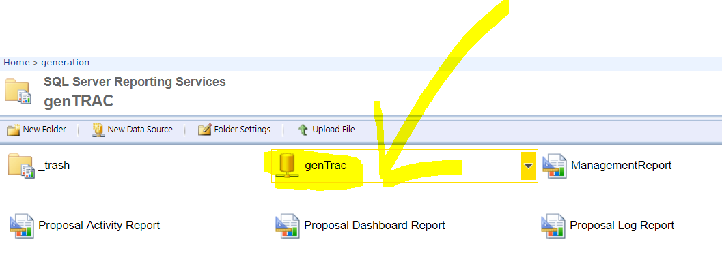
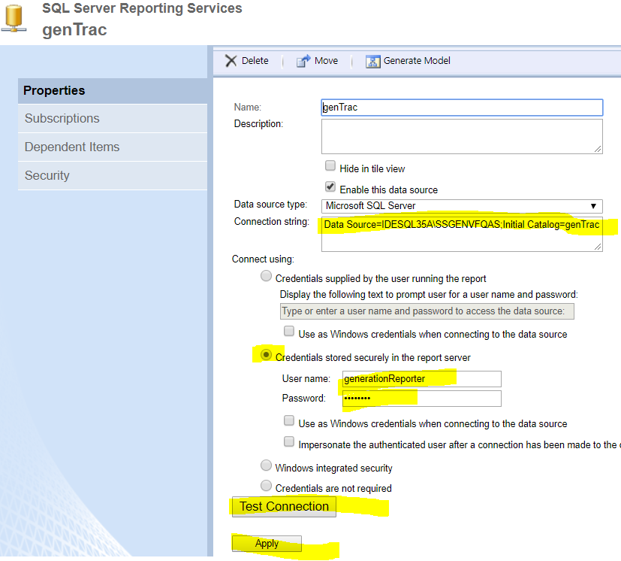
- Assign this data source to the reports, if necessary (I’m not sure if this will be or not)
  - To set the data source, or verify that it’s correct - click on the little down arrow on a report, click on Manage.
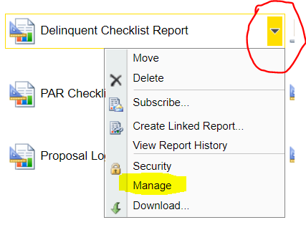
  - Then select data sources on the left. Select a shared data source, browse to it if necessary. Make sure it’s using the credentials supplied in the data source
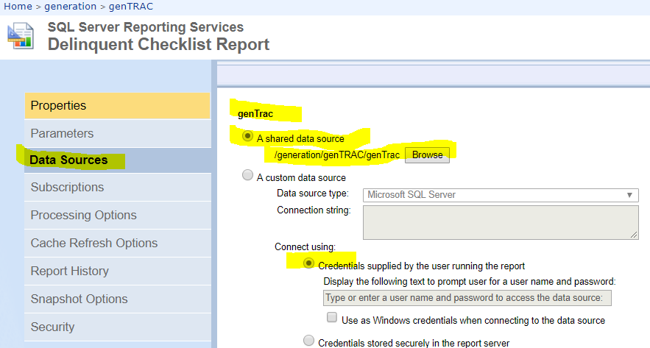

Appendix A: PTM Database Script Customization
Please follow the instructions for your particular situation.

Appendix B: IES Web.Config Customization
- connectionStrings section
  - IESEntities – IES database connection string
- appSettings section
General Settings
  - BOEUrl – GenBOE’s URL
  - PTMUrl – PTM’s URL
  - RDMUrl – RDM’s URL
  - PPUrl – ProPricer URL – a URL to a sharepoint site where ProPricer links are located
  - RPMUrl – blank it out, RPM will not be deployed on the classified side
  - IESPortalAdminGroups – Admin AD group
Piwik Settings
  - DisablePiwik – set this to true (to not track the website usage via piwik)
    - You can ignore the other piwik settings once you disable it
- system.web -> authorization section
  - allow roles – all AD groups allowed to access all of the IES suite applications, including GenBOE
- location path="elmah.axd" -> system.web -> authorization section
  - allow roles – AD groups allowed to view the error logs, some sort of an admin group
- elmah section
  - in errorLog setting, update the connectionString to the same value as the database connection string above
- Remove the HTTPS redirect portion of web.config. Example:
<rewrite>
<rules>
<rule name="Redirect to HTTPs" stopProcessing="true" enabled="true">
<match url="(.*)" />
<conditions>
<add input="{HTTPS}" pattern="^OFF$" />
</conditions>
<action type="Redirect" url="https://{HTTP_HOST}/{R:1}" />
</rule>
</rules>
</rewrite>

Appendix C: PTM Web.Config Customization
- connectionStrings section
  - genTracEntities – PTM database connection string
  - GenBOEEntities – GenBOE database connection string
- appSettings section
General Settings
  - EmailServer – the server to be used to send out application emails
  - ActiveDirectoryPath – the Active Directory server location
  - ServerURL – the URL of the website (your DNS setting)
  - AuthorizeProposalCreationGroups– AD groups allowed to create new proposal; for us this is set to everyone - US\lmco.all.emp
  - DomesticUsersGroup – AD groups containing domestic users, again for us this is set to US\lmco.all.emp
  - HelpdeskEmailAddress – email displayed to the users to contact for help
  - BaseUrlForInstructionLocation – set this to the URL where the instruction files can be located. This path should start with http(s):\\ and end with \. Our location for example is: https://space.p.external.lmco.com/sites/fbo/CCDME/Estimating/Checklist%20Reference%20Documents/
  - IsClassEnvironment – set this to true
SSRS Report Settings
  - ReportServerLocation – URL to the SSRS server
  - ReportServerFolderName – folder name in which the reports are located
Other URLs
  - IESHeaderUrl – if IES portal is installed, put in the URL to it; otherwise leave blank
  - RDSBUrl – if RDSB is installed, put in the URL; otherwise leave blank
  - BOEUrl –put in the for the BOE application
Piwik Settings
  - DisablePiwik² – set this to true (to not track the website usage via piwik)
    - You can ignore the other piwik settings once you disable it
Approval Workflow Role AD Groups
  - LeadEstimators – set this to the appropriate AD group
  - LOBLeads – set this to the appropriate AD group
  - LOBManagers – set this to the appropriate AD group
  - CoverSheetApprovers – set this to the appropriate AD group
  - PricingVerifications – set this to the appropriate AD group
  - IndependentReviewers – set this to the appropriate AD group
- system.web -> authorization section
  - allow roles – AD groups allowed to access PTM (general users as well as the above)
- location path="elmah.axd" -> system.web -> authorization section
  - allow roles – AD groups allowed to view the error logs, some sort of an admin group
- elmah section
  - in errorLog setting, update the connectionString to the same value as the database connection string above
- Remove the HTTPS redirect portion of web.config. Example:
<rewrite>
<rules>
<rule name="Redirect to HTTPs" stopProcessing="true" enabled="true">
<match url="(.*)" />
<conditions>
<add input="{HTTPS}" pattern="^OFF$" />
</conditions>
<action type="Redirect" url="https://{HTTP_HOST}/{R:1}" />
</rule>
</rules>
</rewrite>

Appendix D: RDM Web.Config Customization
- connectionStrings section
  - IESEntities – IES database connection string
- appSettings section
General Settings
  - EmailServer – the server to be used to send out application emails
  - ActiveDirectoryPath – the Active Directory server location
  - ServerURL – the URL of the website (your DNS setting)
  - HelpdeskEmailAddress – email displayed to the users to contact for help
  - IESHeaderUrl – if IES portal is installed, put in the URL to it; otherwise leave blank
  - LMIProxy – proxy used during image processing
  - EstimatingDataGroupDL– blank it out¹
Piwik Settings
  - DisablePiwik² – set this to true (to not track the website usage via piwik)
    - You can ignore the other piwik settings once you disable it
RDM AD Roles
  - RDMAdminGroups – admin users;
  - RDMCobraAdminGroups – cobra admin users;
  - RDMViewerGroups – all users that need to have read access to the system;
- system.web -> authorization section
- allow roles – AD groups allowed to access the app, at the minimum all of the above
- location path="elmah.axd" -> system.web -> authorization section
- allow roles – AD groups allowed to view the error logs, some sort of an admin group
- elmah section
- in errorLog setting, update the connectionString to the same value as the IES database connection string above
- Remove the HTTPS redirect portion of web.config. Example:
<rewrite>
<rules>
<rule name="Redirect to HTTPs" stopProcessing="true" enabled="true">
<match url="(.*)" />
<conditions>
<add input="{HTTPS}" pattern="^OFF$" />
</conditions>
<action type="Redirect" url="https://{HTTP_HOST}/{R:1}" />
</rule>
</rules>
</rewrite>

Appendix E: RDSB Web.Config Customization
- connectionStrings section
  - genTracEntities – PTM database connection string
  - IESEntities – IES database connection string
- appSettings section
General Settings
- ActiveDirectoryPath – the Active Directory server location
- PTMURL – PTM URL
- AuthorizeViewWhosOnlineGroups – admin group
- IESHomeUrl – IES URL
Piwik Settings
- DisablePiwik² – set this to true (to not track the website usage via piwik)
    - You can ignore the other piwik settings once you disable it
- system.web -> authorization section
- allow roles – AD groups allowed to access the app, at the minimum all of the above
- location path="elmah.axd" -> system.web -> authorization section
- allow roles – AD groups allowed to view the error logs, some sort of an admin group
- elmah section
- in errorLog setting, update the connectionString to the same value as the IES database connection string above
- Remove the HTTPS redirect portion of web.config. Example:
<rewrite>
<rules>
<rule name="Redirect to HTTPs" stopProcessing="true" enabled="true">
<match url="(.*)" />
<conditions>
<add input="{HTTPS}" pattern="^OFF$" />
</conditions>
<action type="Redirect" url="https://{HTTP_HOST}/{R:1}" />
</rule>
</rules>
</rewrite>

Appendix F: PTM Emailer - App.Config Customization
- connectionStrings section
  - genTracEntities – PTM database connection string
- appSettings section
  - EmailServer – the server to be used to send out application emails
  - ServerURL – the URL of the website (your DNS setting)
  - HelpdeskEmailAddress – email displayed to the users to contact for help
- elmah section
  - in errorLog setting, update the connectionString to the same value as the database connection string above

Appendix G: RDM Data Replication - App.Config Customization
- connectionStrings section
  - IESEntities – IES database connection string
- appSettings section
  - EmailServer – the server to be used to send out application emails
  - EmailDistributionList – emails for users that need to be notified of data loads. At the minimum Frank’s email, possibly other admins as well; comma separated list, if multiple are needed;
  - HelpdeskEmailAddress – email displayed to the users to contact for help
  - RdmSearchFolder – the account has to have full access to this folder; the folder has to exist ahead of time; this is where the security will place files once they are moved from unclassified location;
  - RdmArchiveFolder – the account has to have full access to this folder; the folder has to exist ahead of time; suggested location would be an “Archive” folder in the folder above
  - RdmClearRevisionCacheUrl – URL of the RDM application, pointing to a specific view; pattern of what it needs to be set to (where RdmURL represents the URL of the application) is : http(s)://RdmURL/Admin/ClearRevisionCache

- elmah section
  - in errorLog setting, update the connectionString to the same value as the database connection string above

Appendix H: GenBOE Auto Backup - App.Config Customization
- connectionStrings section
  - GenBoeEntities – GenBOE database connection string
- appSettings section
  - EmailServer – the server to be used to send out application emails
  - SendEmailTo – Frank’s email address
  - HelpdeskEmailAddress – email displayed to the users to contact for help
- elmah section
  - in errorLog setting, update the connectionString to the same value as the database connection string above

The blanked out entry will look like this: <add name="RPMUrl" value=""/>, having its value set to an empty/blank text.
Assuming you are not using Piwik

